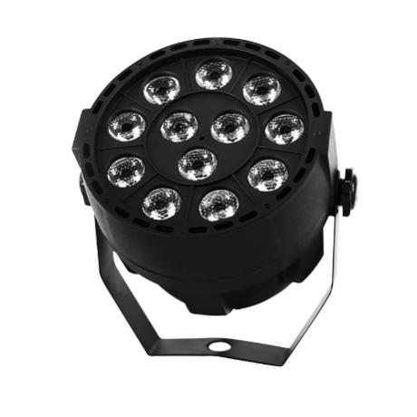
LED Flat Par 12x3W Violet Color Lighting
Maintenance
1.Please keep the light in dryness and avoiding use in wet place.
2.Using intermittenlly can be extended the life.
3.Attention to clean the fan and lens usually in order to get the ventilating effects and lighting effects better.
4.Please do not wipe the crust using organic menstruum for avoid to damaged the product.

Statement
The product has well capability and intact packing when leave factory,All of the user should comply with above warning item and manual ,any misuse cause of the damages are not included in our guarantee,and also can’t be responsible for any malfunction & problem owing to ignore the manual.
Please forgive that we will not be notice for technical change

Attention Item
1.For guarantee the life of product,please do not put it on the wet place and not use it the place over 40 degree.
2.Please don’t lay the product on the un-fixable or shakable place.
3.Ask for the professional to maintain the product in order to avoid the danger of get an electric shock.
4.Power supply should not be changed over +&-10% while the light is using,it will be decreased the life of lamp if the power is too high,but it will be influenced the luminosity if the power is too low.
5.After power off,if it is need used again,please cool down over 20 minuter.
6.Please look round the manual for ensure the product can be used normally.

DMX Channel Summary-8 Channels Mode
Channel | Value | Function
CH1 | Total Dimming | Total dimming
CH2 | 0--255 | Purple 1 dimming
CH3 | 0--255 | Purple 2 dimming
CH4 | 0--255 | Purple 3 dimming
CH5 | 0--255 | Purple 4 dimming
CH6 | Total Strobe | Strobe from fast to slow
CH7 | 0-250 | Auto
 | 251-255 | Sound
CH8 | CH7 control speed | Control speed for CH7, Auto+Sound Mode

Display Control Instruction
No | Display | Function
1 | A001 | 0-512, DMX Mode
2 | Adye | Adye/Adno, NO
3 | Au01 | 01--08, light mode(8 kinds)
4 | FF90 | 0-99, between the colorful gradient and colorful jump
5 | EE90 | 0-99, colorful gradient
6 | CC90 | 0-99, colorful jump
7 | F000 | 0-255, colorful gradient
8 | Strobe | R, G, B, W, A flash, from slow to fast
9 | Sound | Sound Mode
10 | r255 | 0--255,Purple 1 dimming
11 | g255 | 0--255, Purple 2 dimming
12 | b255 | 0--255, Purple 3 dimming
13 | w255 | 0--255, Purple 4 dimming
No | Display | Function

Display Control Instruction
Welcome to use our light.The light uses energy-saving LED,long Product life,shockproof,dustproof, DMX receiver and self-running feature, which can produce a variety of vivid lighting effects,easy to operate, suitable for all types of entertainment decoration,architectural lighting industry.
E
A:Function
B:Up
C:Down
D:Enter
E:LED Display

A B C D
Instructions:Press the function key A cycled out the eight different function effects,digital tube first two digits on behalf of which the current function(see menu).The last two digits represent the functions in which the address code or speed parameters.Press the B or C key to modify the parameter values.Press the D key to confirm.

Product Introduction
* Power Supply:AC90--275V,50--60HZ
* Power consumption:36W
* Fixing lamp:LED 12×3W Violet Color
* DMX-Control-channels:8 DMX Channels
* Shuttle:Flash rate:0--10HZ
* Dimmer:0-100% mechanic dimmer
* Long Lifespan LEDs(more than 60,000 hours)

