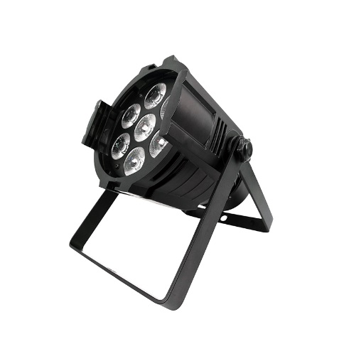
(Mini) Aluminum alloy LED Par 7x18W RGBWA+UV
Lighting
Maintenance
1.Please keep the light in dryness and avoiding use in wet place.
2.Using intermittenlly can be extended the life.
3.Attention to clean the fan and lens usually in order to get the ventilating effects and lighting effects better.
4.Please do not wipe the crust using organic menstruum for avoid to damaged the product.

Statement
The product has well capability and intact packing when leave factory,All of the user should comply with above warning item and manual ,any misuse cause of the damages are not included in our guarantee,and also can’t be responsible for any malfunction & problem owing to ignore the manual.
Please forgive that we will not be notice for technical change

Attention Item
1.For guarantee the life of product,please do not put it on the wet place and not use it the place over 40 degree.
2.Please don’t lay the product on the un-fixable or shakable place.
3.Ask for the professional to maintain the product in order to avoid the danger of get an electric shock.
4.Power supply should not be changed over +&-10% while the light is using,it will be decreased the life of lamp if the power is too high,but it will be influenced the luminosity if the power is too low.
5.After power off,if it is need used again,please cool down over 20 minuter.
6.Please look round the manual for ensure the product can be used normally.

DMX Channel Summary-6 Channels Mode
Channel | Value | Function
1 | 0-255 | Red light color control, channel value of 0 for the closed light, 1~255 for the red light adjustment
2 | 0-255 | Green light color control, channel value of 0 for the closed light, 1~255 for the red light adjustment
3 | 0-255 | Blue light color control, channel value of 0 for the closed light, 1~255 for the red light adjustment
4 | 0-255 | White light color control, channel value of 0 for the closed light, 1~255 for the red light adjustment
5 | 0-255 | Amber light color control, channel value of 0 for the closed light, 1~255 for the red light adjustment
6 | 0-255 | Violet light color control, channel value of 0 for the closed light, 1~255 for the red light adjustment

DMX Channel Summary-10 Channels Mode
Channel | Value | Function
 | 0-255 | R,G,B,W,A,UV total dimming,linear dimming form dark to light
 | 0-255 | Red dimming,Linear dimming form dark to Bright
 | 0-255 | Green dimming,Linear dimming form dark to Bright
 | 0-255 | Blue dimming,Linear dimming form dark to Bright
 | 0-255 | White dimming,Linear dimming form dark to Bright
 | 0-255 | Amber dimming,Linear dimming form dark to Bright
 | 0-255 | Violet dimming,Linear dimming form dark to Bright
 | 0-255 | Strobe -RBGWA UV
 | 0-255 | NO Effect  Auto Mode 1  Auto Mode 2  Auto Mode 3  Sound Mode
 | 0-255 | Function Speed Adjustment -CH9

Display Control Instruction
No | Display | Function
1 | d001 | 8-channel address code,（001--512）  B，C key addition and subtraction address code value
2 | CC01 | Colorful jump, (001-99) through the [UP] key or [DOWN] down key to modify the speed of the jump
3 | CP01 | Colorful gradient, (001-99), through the [UP] key or [DOWN] down key to modify the speed of the gradient
4 | dE00 | Enter the display menu for the program demo mode, the program from the walk through the [UP] key or [DOWN] down key to modify the speed of the speed
5 | BEBE | The display menu to voice mode, through sound trigger transformation of a different color.  Note: voice function test, attention should be paid to the level of sound sensitivity, and adjusting the driving plate to fine tune the position to get the best sensitivity to enter
6 | R001 | Red color selection, (001-255) through the [UP] up or [DOWN] down key to modify the red light brightness
7 | G001 | Green color selection, (001-255) through the [UP] key or [DOWN] down key to modify the green brightness
8 | B001 | Blue color selection, (001-255) by the "UP" key or "DOWN" down key to modify the blue brightness
9 | W001 | White color selection, (001-255) through the [UP] up or [DOWN] down key to modify the blue brightness

Display Control Instruction
Welcome to use our light.The light uses energy-saving LED,long Product life,shockproof,dustproof, DMX receiver and self-running feature, which can produce a variety of vivid lighting effects,easy to operate, suitable for all types of entertainment decoration,architectural lighting industry.
E
A:Function
B:Up
C:Down
D:Enter
E:LED Display

A B C D
Instructions:Press the function key A cycled out the eight different function effects,digital tube first two digits on behalf of which the current function(see menu).The last two digits represent the functions in which the address code or speed parameters.Press the B or C key to modify the parameter values.Press the D key to confirm.

Product Introduction
* Power Supply:AC90--275V,50--60HZ
* Power consumption:126W
* Fixing lamp:LED 7×18W RGBWA UV
* DMX-Control-channels:6/10 DMX Channels
* Shuttle:Flash rate:0--10HZ
* Dimmer:0-100% mechanic dimmer
* Long Lifespan LEDs(more than 60,000 hours)

